Welcome to the thingSoC® USBUART2
The TSOC_USBUART2 is an dual channel, USB bridge based on the Cypress Semicondutor CY7C65215A device, in an Embedded Module format for the new thingSoC, Internet of Things open source hardware standard.
Getting Started :
The TSOC_USBUART2 provides two (2) USB bridge ports that can be configured to support UART, I2C, SPI, GPIO, CapSense, or JTAG interfaces.
1) Plug a USB Micro cable into the TSOC_USBUART2 and you Windows, Linux or Apple PC.
2) After a few (long) minutes, your drivers should be loaded automatically.
(Be patient this can often take 15 minutes or longer the very first time.)
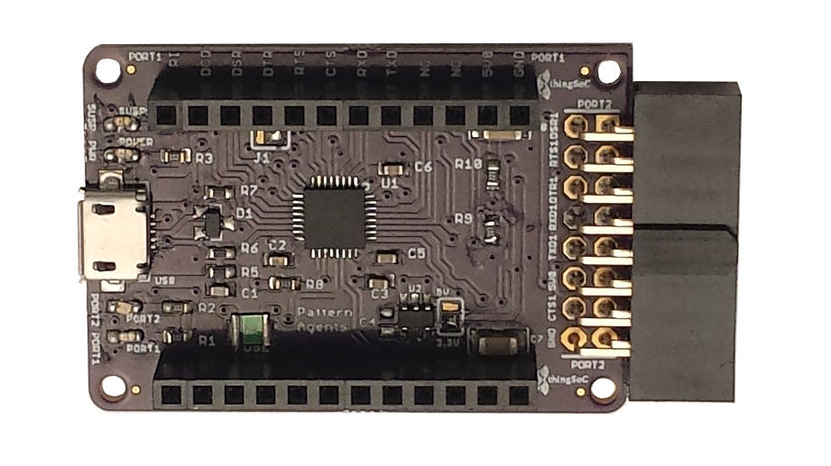
3) If the drivers are not automatically installed, please manually download them from :
http://www.cypress.com/documentation/other-resources/usb-serial-drivers

4) If you would like to modify the TSOC_USBUART2 configuration (change from UART to I2C, etc.)
then you will need to download and install the Cypress USB-Serial SDK. It can be found at :
http://www.cypress.com/documentation/software-and-drivers/usb-serial-software-development-kit

Safe Handling Precautions :
1) Always remove/unplug all power before inserting or removing peripherals.
2) Always ground yourself by touching a ground point before handling your boards.
3) Use a static safe bag when transporting your TSOC_USBUART2 board.
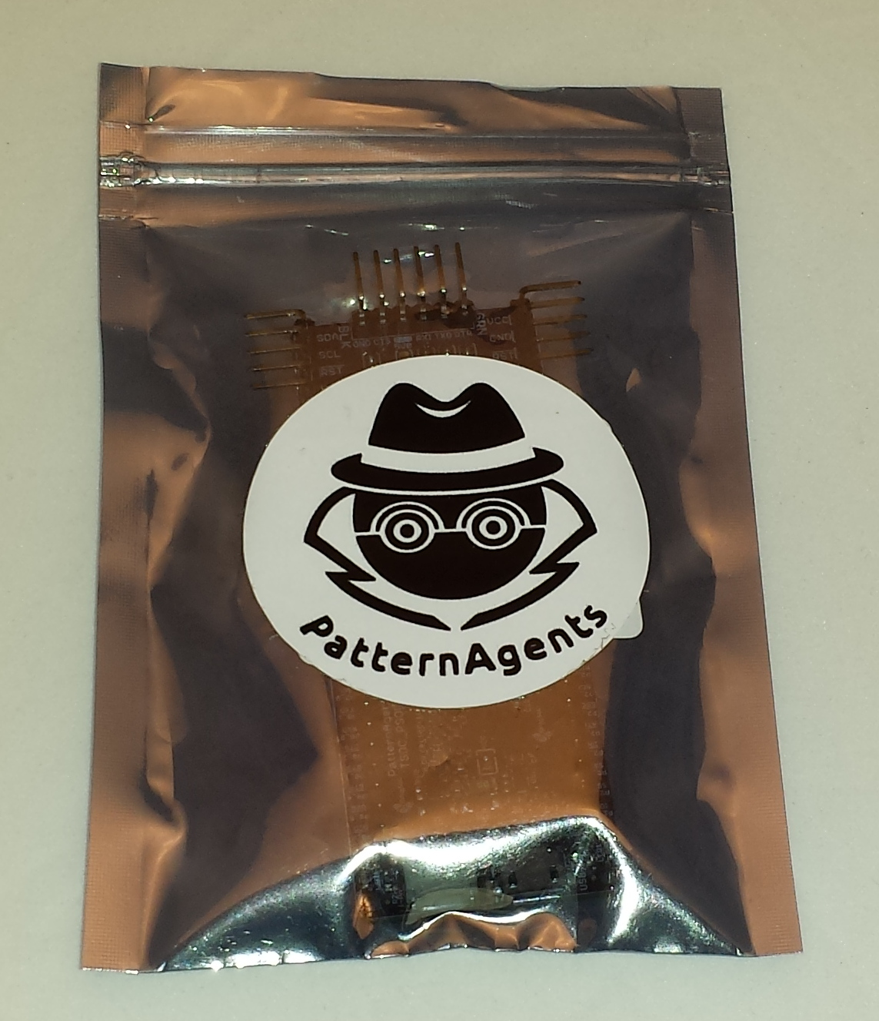

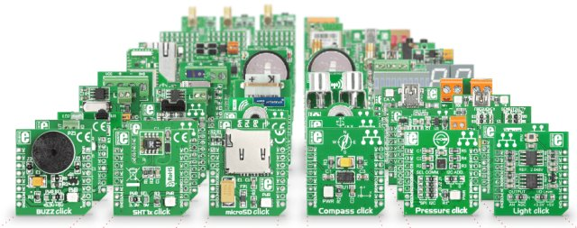
Adding Mikrobus Peripherals :
The TSOC_USBUART2 board supports Mikrobus and Mikroe "Click" peripherals.
1) Make sure to align the SQUARE/CUT edges of the Mikrobus board together to insure that
the polarity is correct. Push down evenly to seat the boards in the socket.
2) Note that the "stacking pins" are somewhat longer by design, and there will be some
extra space between the boards when using stacking connectors.
thingSoC® USBUART2 Application Examples :

USB to RS-485 Adapter:
Insert the Mikroe "Click" RS-485 Adapter in the USBUART as follows :
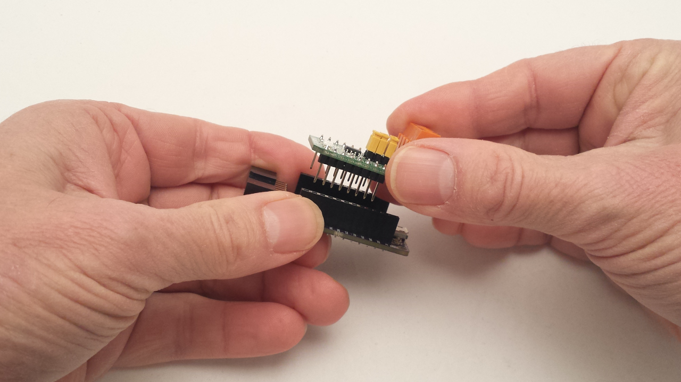
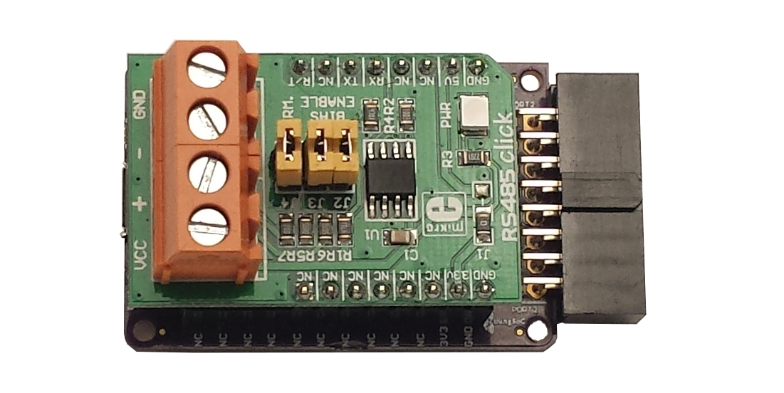

USB to GSM Adapter:
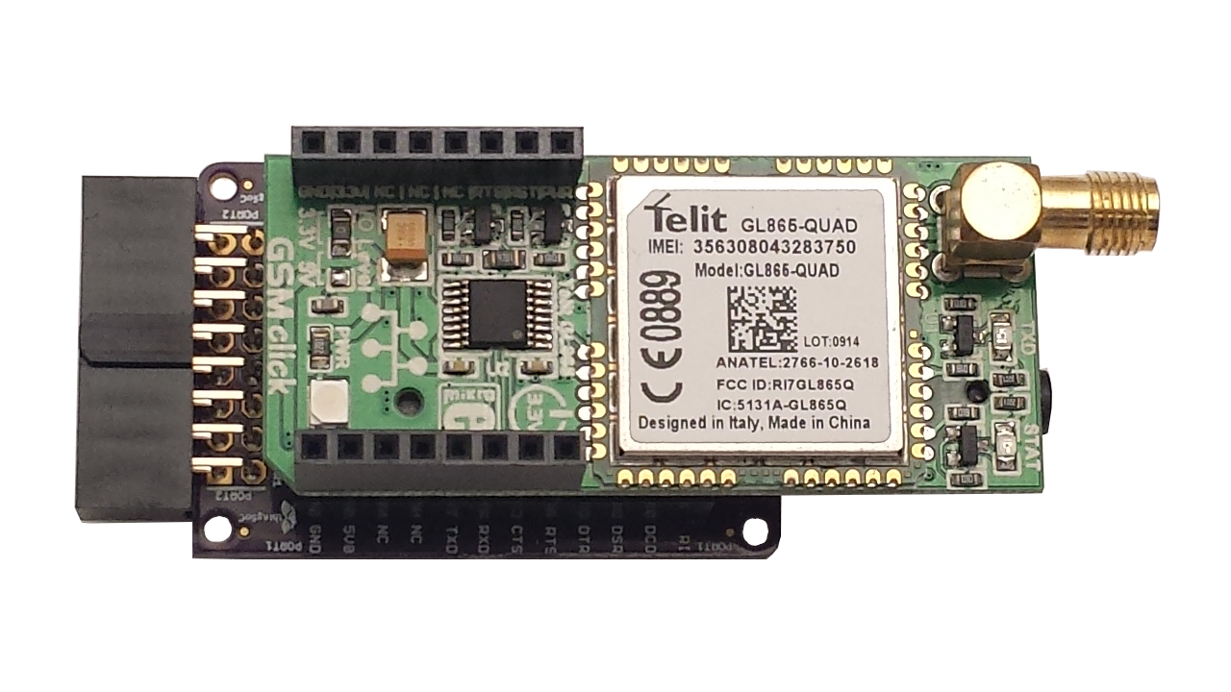
USB to Wi-Fi Adapter :

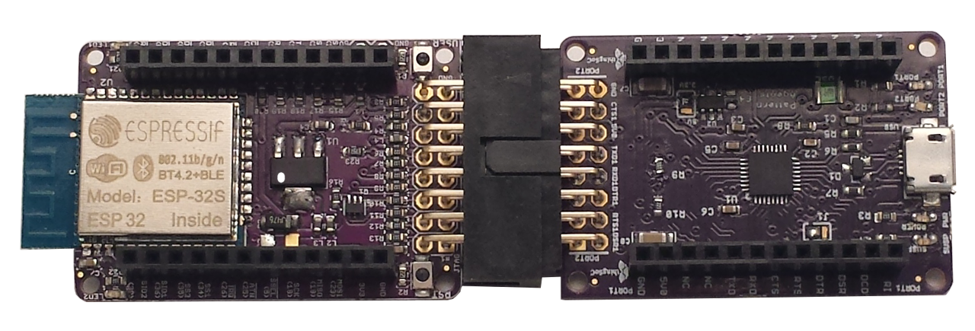

Using USBUART2 as an "FTDI" Replacement :

The TSOC_USBUART2 has extra pins to implement the "nodeMCU" programming protocol, which requires the RTS (Request to Send) handshake signal in addition to DTR (Data Terminal Ready) which is normally found on "FTDI" type programmers. Simply use a six (6) pin header to adapt the connector to older FTDI devices as shown below :

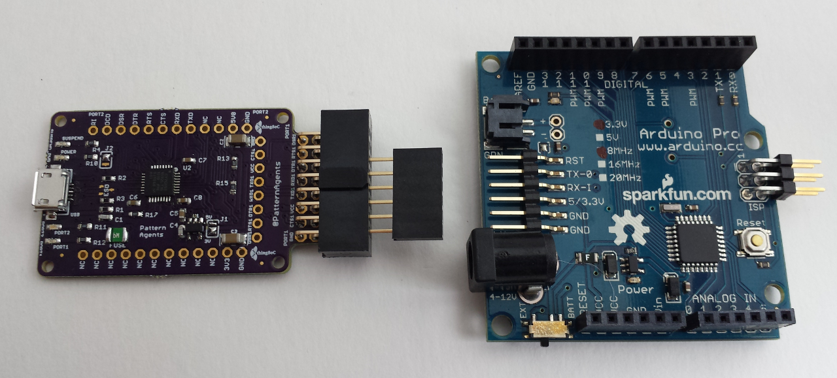

For more information and examples :

The TSOC_USBUART2 is an open source hardware project from PatternAgents, LLC,
and you are free to build your own boards if you wish.
Complete documentation, including schematics, layouts, gerbers, and Bill of Materials (BOM) are available on the thingSoC website at :
https://github.com/thingSoC/TSOC_USBUART2/tree/master/TSOC_USBUART2

There is also a project Wiki available for asking questions and more information at :
https://github.com/thingSoC/TSOC_USBUART2/wiki

thingSoC® USBUART2 Features :
The TSOC_USBUART2 is a low cost, embeddable module featuring a Cypress Semiconductor CY7C65215A Dual USB bridge device :
- CY7C65215A Dual USB Bridge
- Two (2) Configurable USB Interfaces
- Supports UART, I2C, SPI, GPIO, CapSense, or JTAG interfaces
- 3.3 Volt or 5.0 Volt operation
- Data rates up to 3.0 Mbps
- UART configurable as 2, 4, 6, 8 pins with full handshaking
- Unique Serial Number per device
- BCD (Battery Charger Detect)
- Low Standby Current with USB suspend mode
- Builtin ESD protection
- Four LED indicators (Power, Suspend, Port1, Port2)
- thingSoC Compliant Module
- Mikrobus Compatible Module



